Tetra Routine Vertiv

Send results to <Carina.Smyth@eir.ie>
Password to 9.2: uPyu5%Q,dejQ0)Xv+

Min / no of battery | 1 | 2 | 3 | 4
0 min
5 min
10 min
20 min
30 min
40 min
50 min
60 min

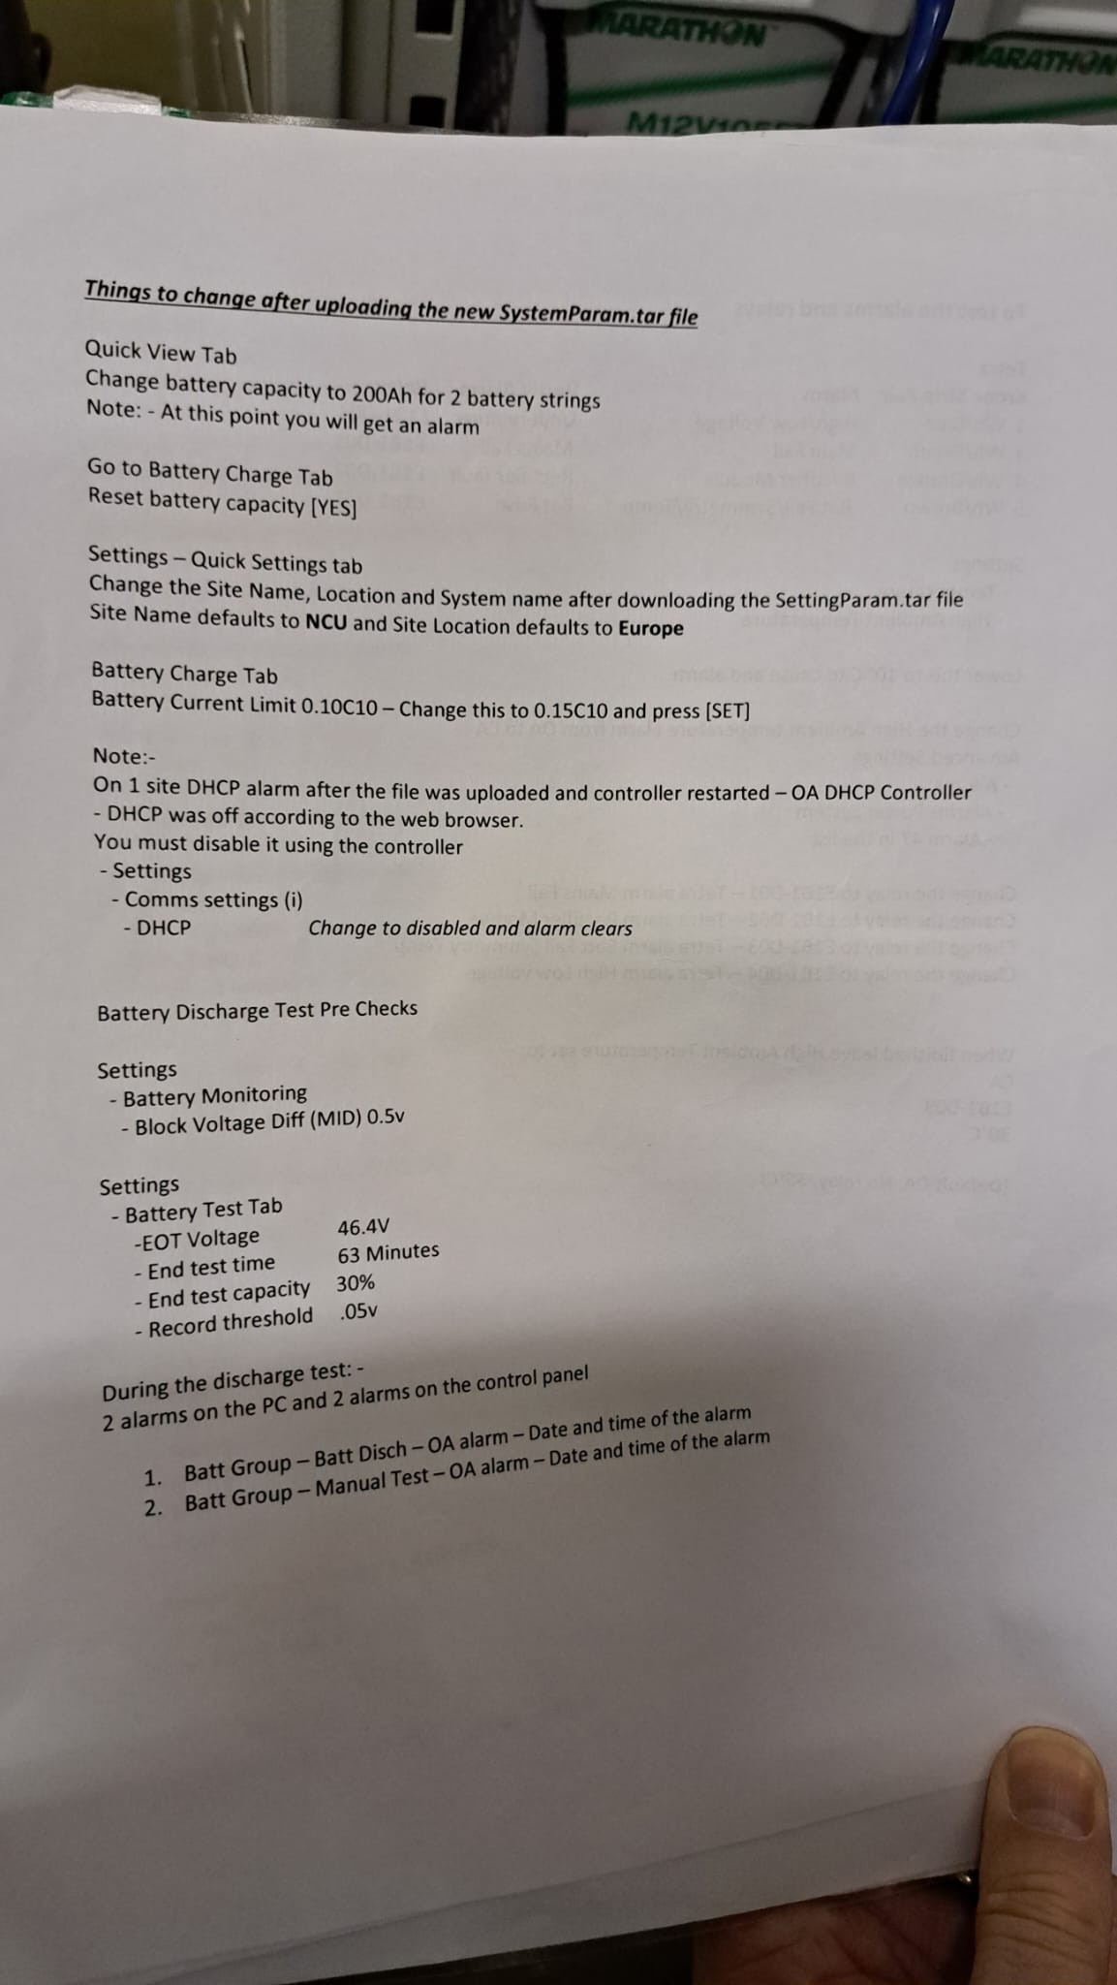

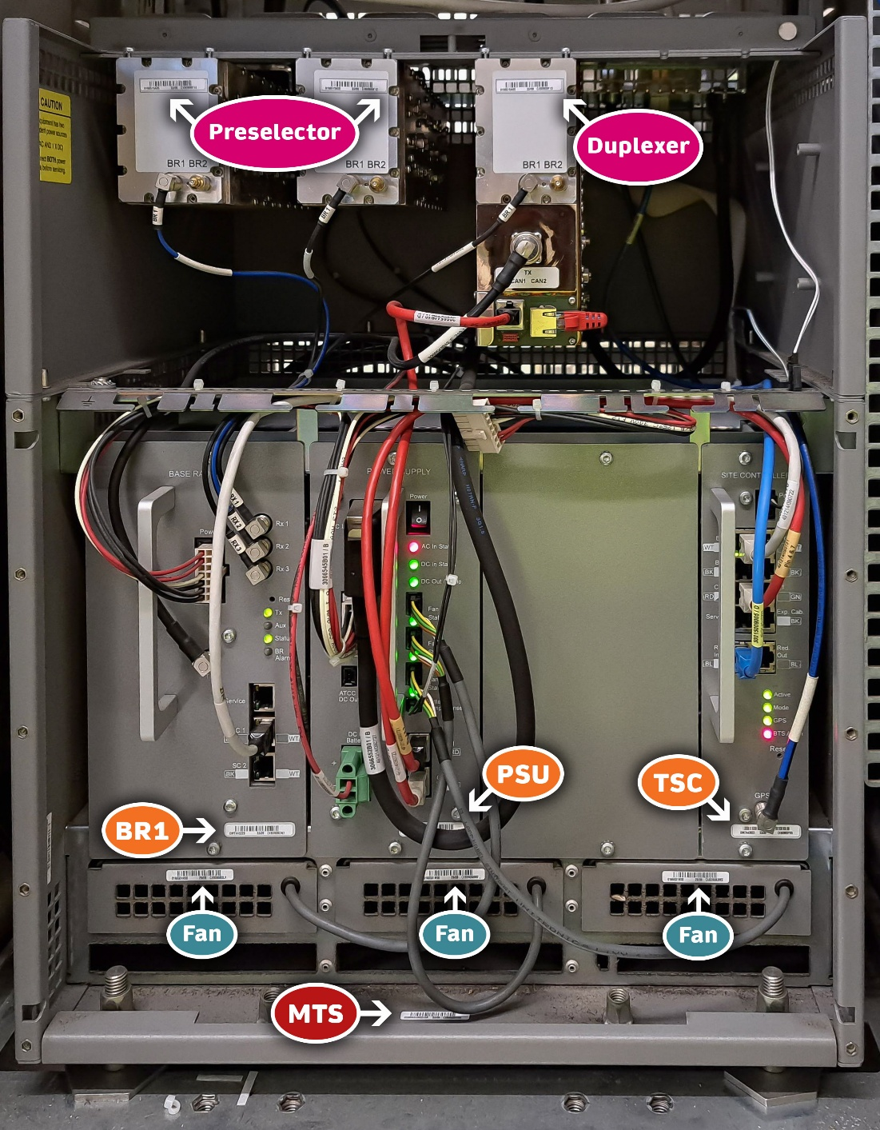
Call SMC to let them know you are about to open the Tetra cabinet.
1800 407 000 →
(1) Front Office →
(3) Managed Services
Switch off VPN and Wi-Fi (offline) (clear the cache)
Open Network Settings: ncpa.cpl  Change IP address to: 192.168.100.99  Admin password is needed for this change. | 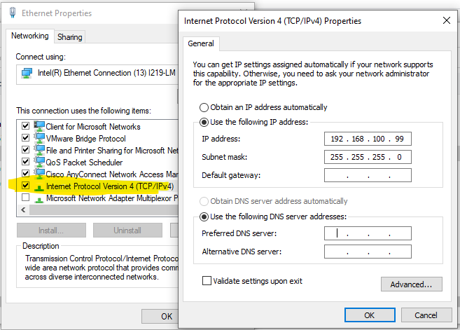
Connect CAT5 cable to the laptop and Vertiv | 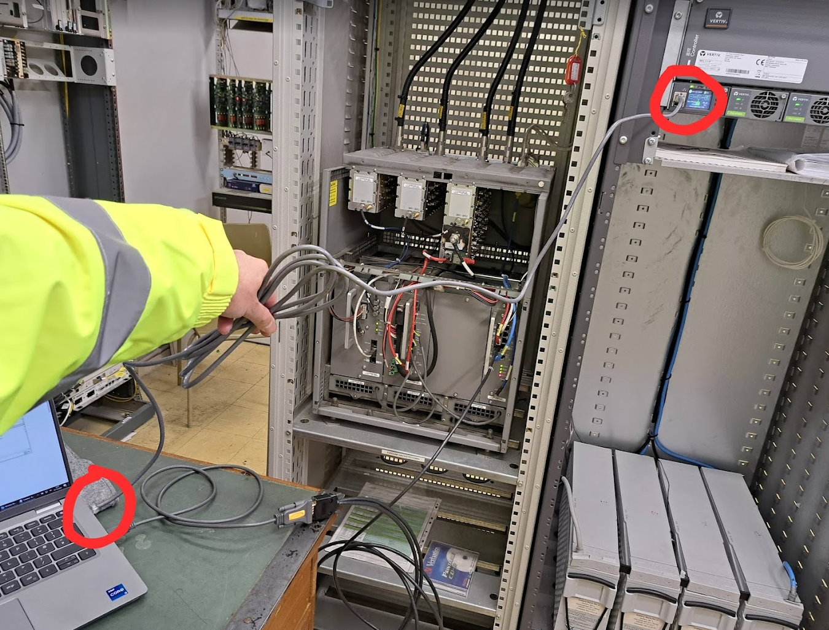
Connect the serial to USB cable + black "Tetra" cable to the USB on the laptop and the other end to the Site Controller → Service port | 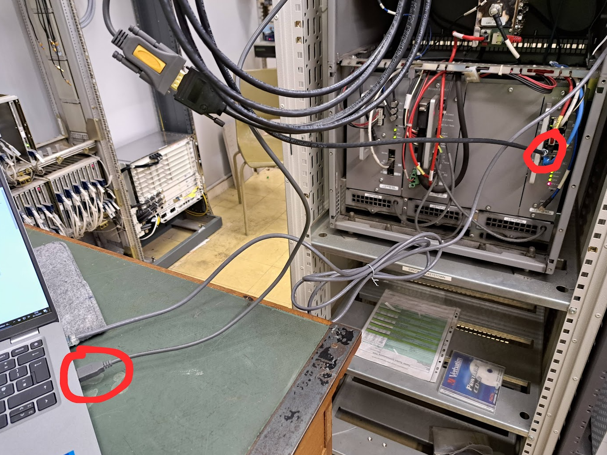  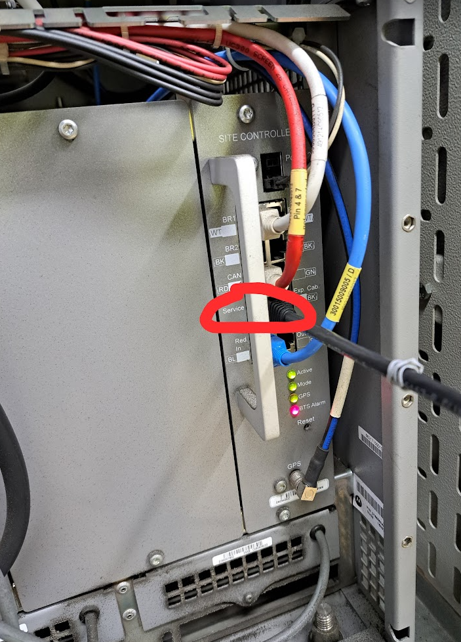
Login to the  http://192.168.100.100  Login: admin  Password: 640275 | 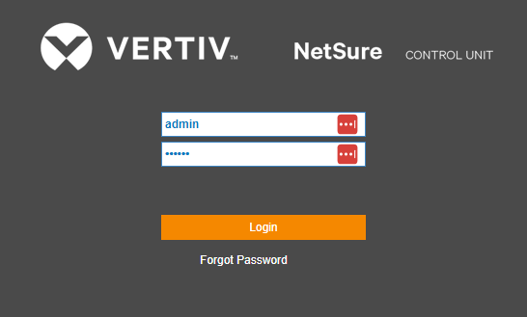
The flow of the electricity before discharge. | 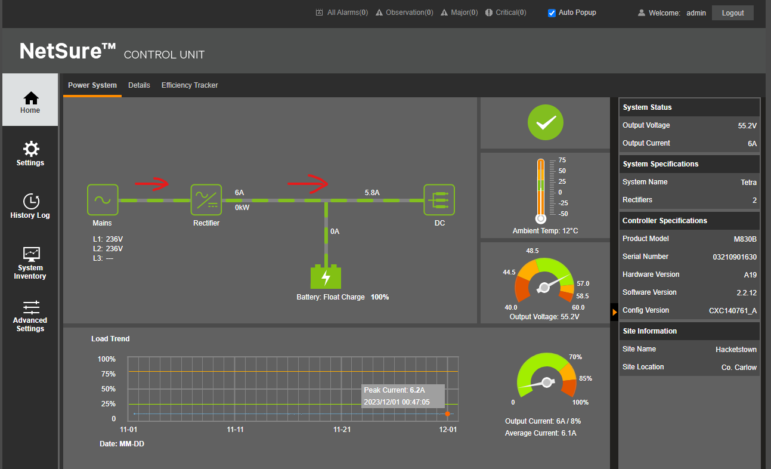
Check if the battery capacity is correct  Settings → Quick Settings → Battery1 Rated Capacity  For 1 set of Batteries is 100 Ah  For 2 sets of Batteries is 200 Ah | 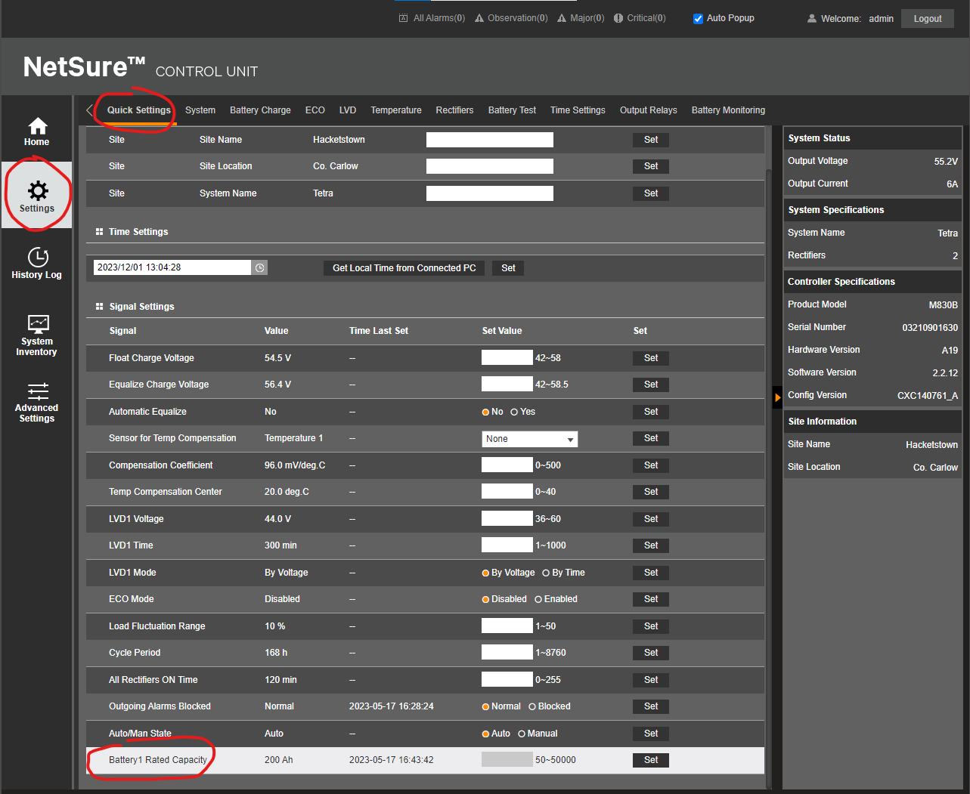
Change the Battery Current Limit to: 0.15 C10  Settings → Battery Charge → Battery Current Limit | 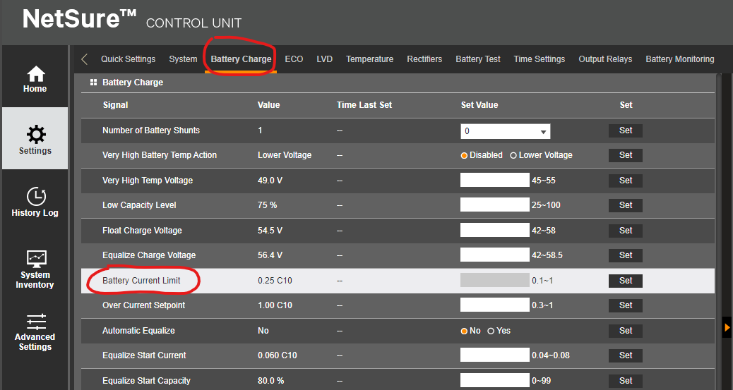
Change the Block Voltage Diff(Mid) to: 0.5 V  Settings → Battery Monitoring → Block Voltage Diff(Mid) | 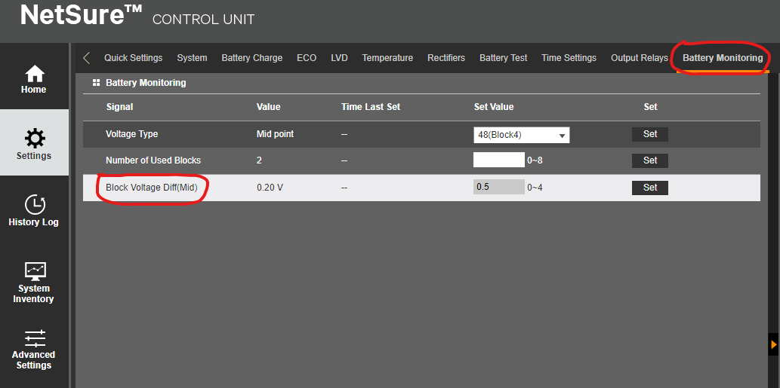
Check the setting in the:  Settings → Battery Test  End Test Voltage: 46.4 V  End Test Time: 63 min  End Test Capacity: 30 %  Record Threshold: 0.05 V | 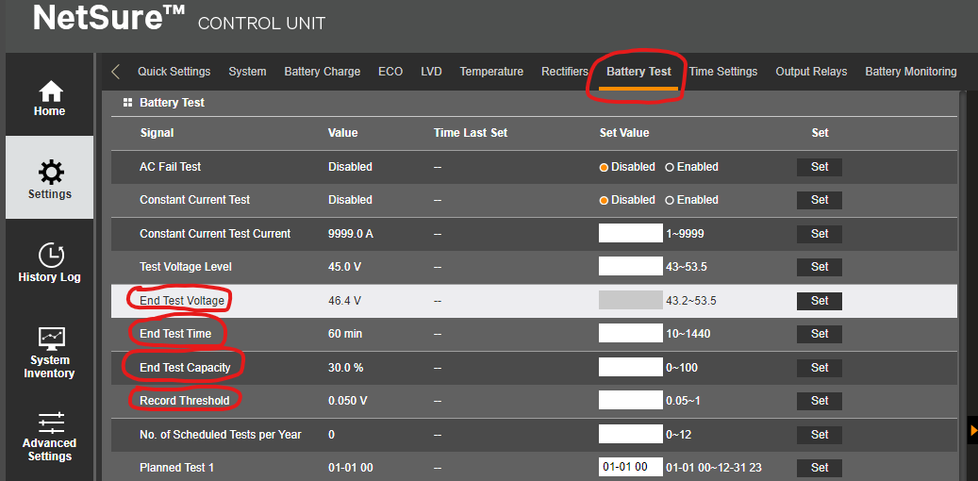
Take the battery reading before the test:
Start the test  Settings → Battery Test → Battery Test Control  Choose Start and click Set | 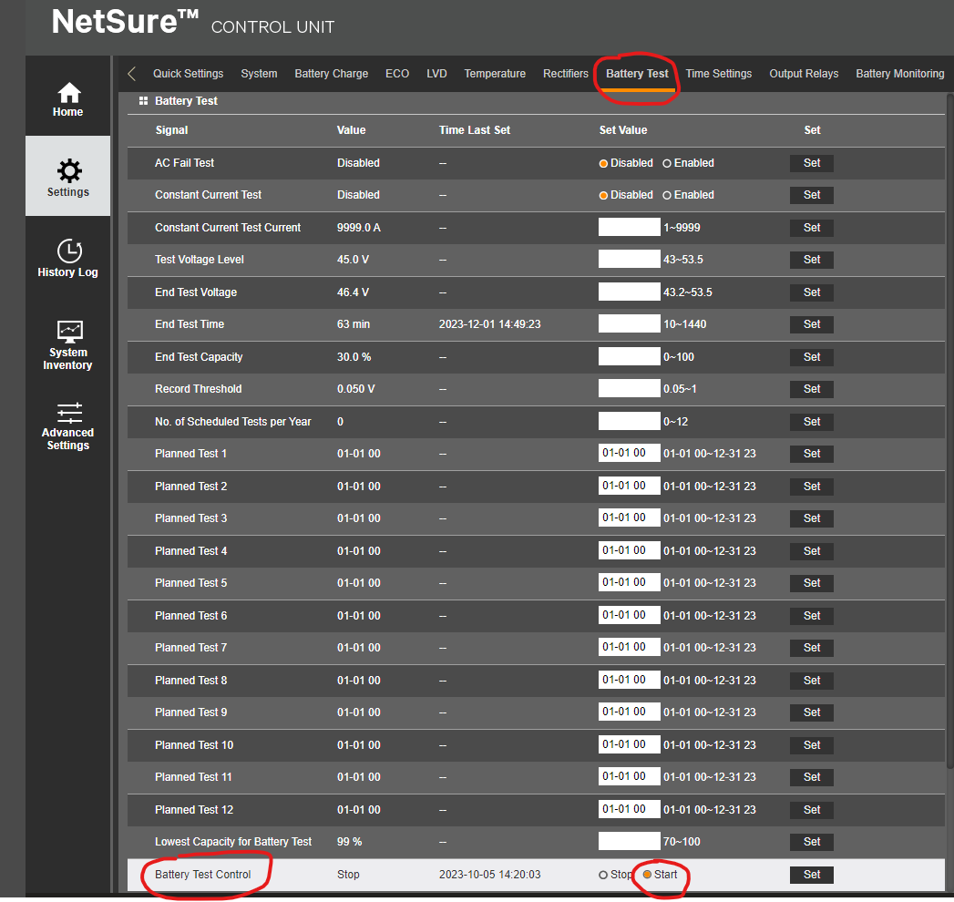
2 observation alarms will show up:  - Battery Discharge  - Manual Test  Also the electricity flow has change:  - Coming from Mains  - Coming from the batteries | 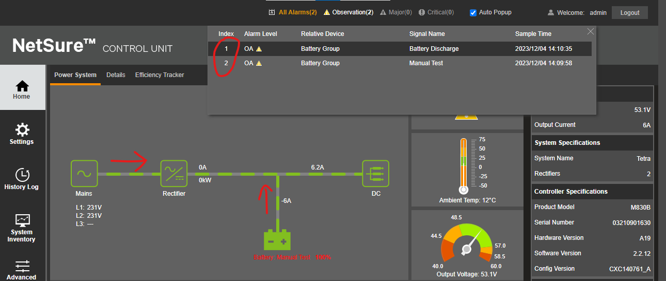
Take the battery readings: | Battery 1 Min / no of battery Temperature 1 2 3 4 0 min 5 min 10 min 20 min 30 min 40 min 50 min 60 min Battery 2 Min / no of battery Tempoerature 1 2 3 4 0 min 5 min 10 min 20 min 30 min 40 min 50 min 60 min
After the test the battery will start charging again.  The 2 alarms will disappear too. | 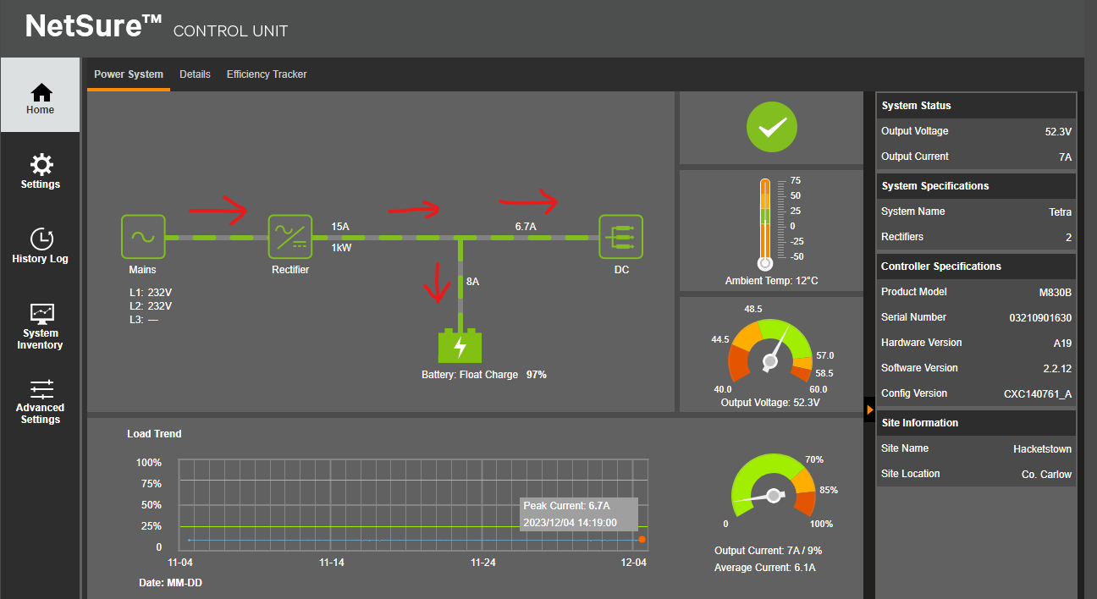
C:\ProgramData\Microsoft\Windows\Start Menu\Programs\Dimetra Service Software  "BTS Service Software"  MTS2  Sys*mgr234%^  admin  factory  status eas -p9 | 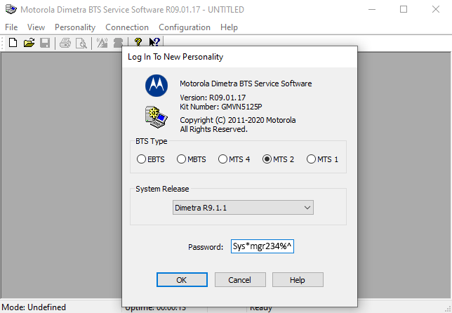  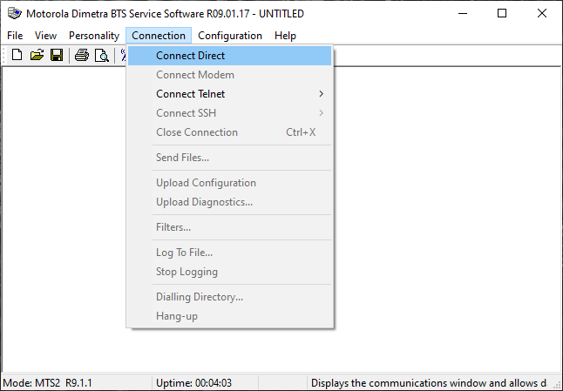  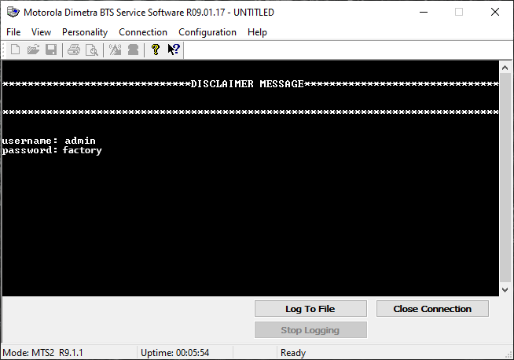
Faults Mapping  Critical: E1B1 - DO5  Under Voltage 1: E1B1 - DO4  Under Voltage 2: E1B1 - DO4  Mains Failure: E1B1 - DO1  Temperature: E1B1 - DO | Critical: E1B1 - DO5  Under Voltage 1: E1B1 - DO4  Under Voltage 2: E1B1 - DO4  Mains Failure: E1B1 - DO1  Temperat  ure: E1B1 - DO3
 | 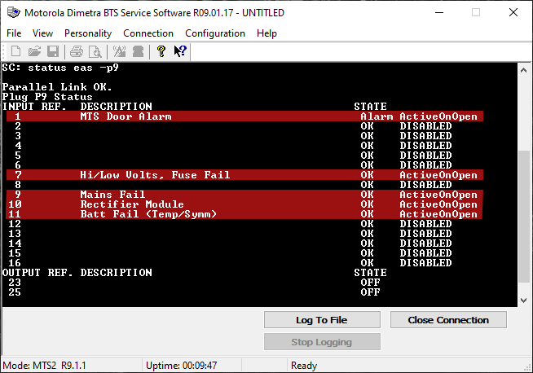
status eas -p9 | 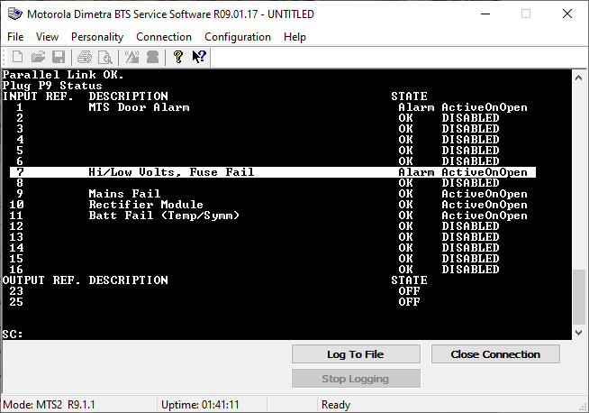  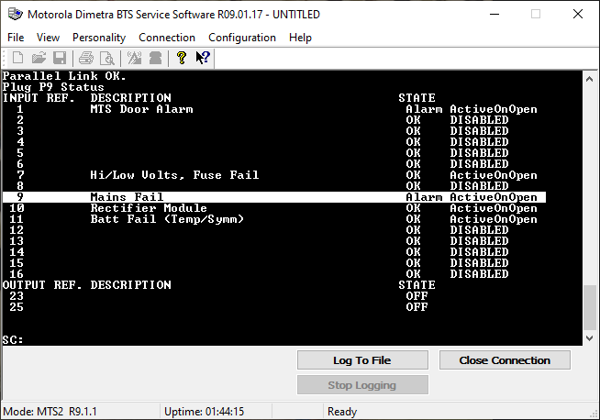    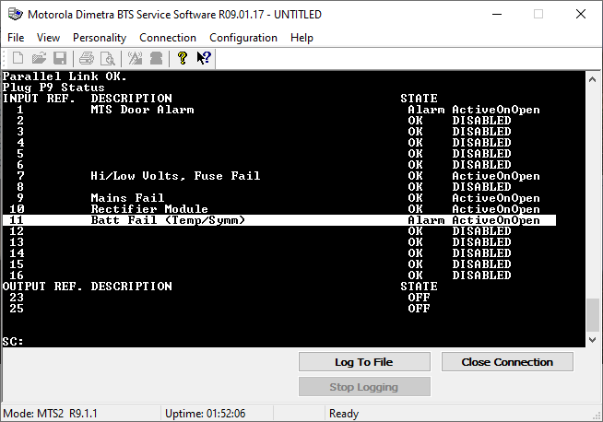
Alarms Test | 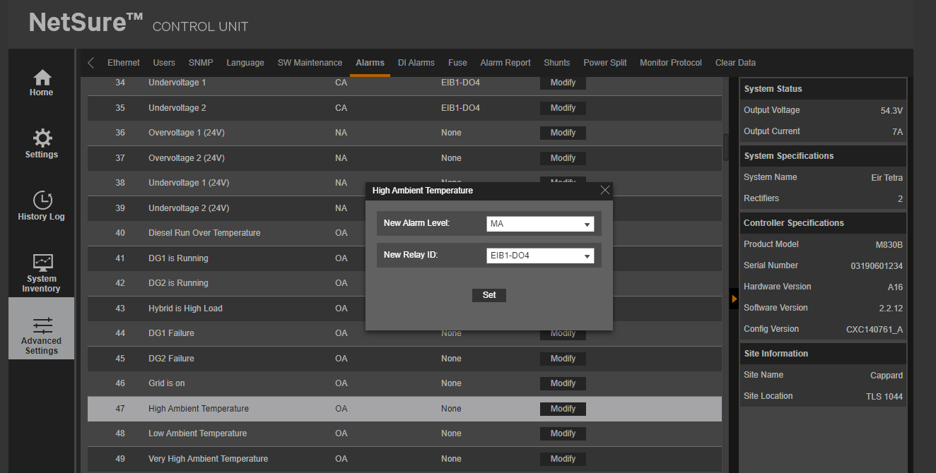
 | 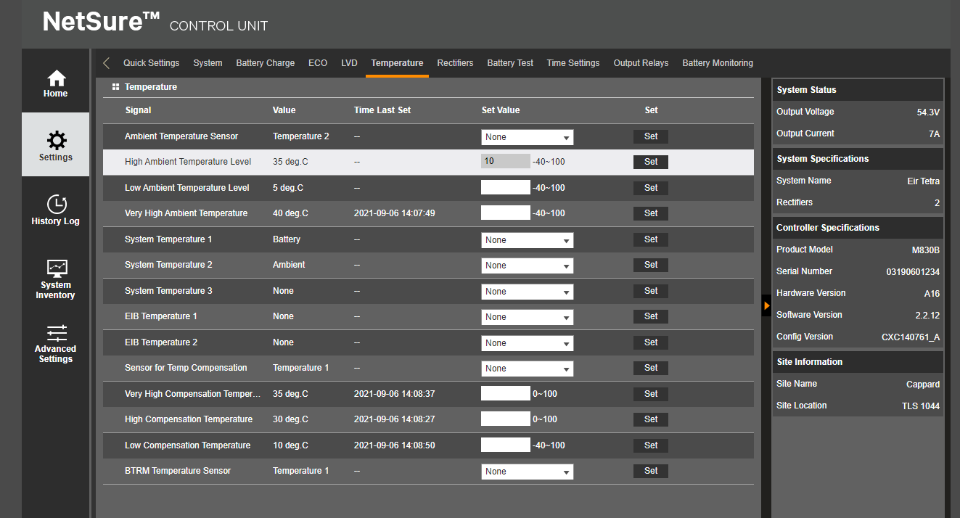
 | 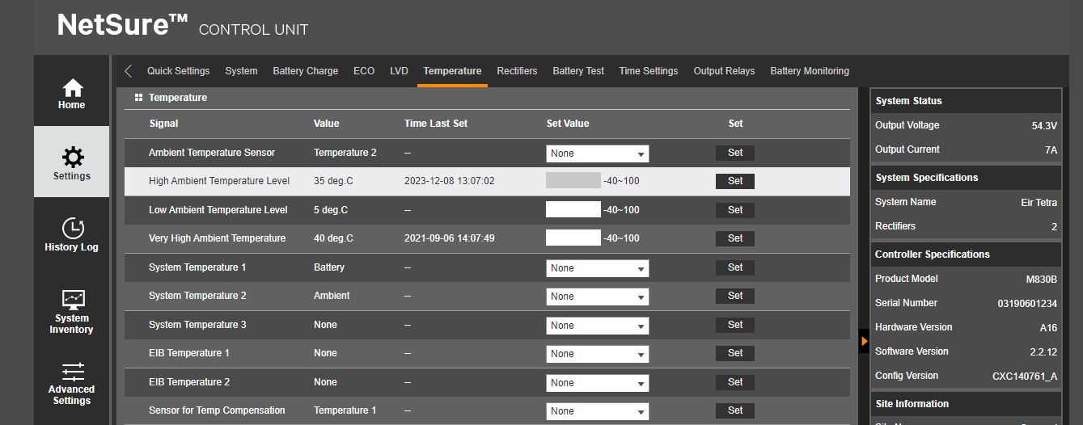
Take down all serial numbers:  Send results to Orna Farrell <orna.farrell@eir.ie> | 
Call SMC to let them know you are closed the Tetra cabinet.
1800 407 000 →
(1) Front Office →
(3) Managed Services

